QUESTION BANK
d AND f BLOCK ELEMENTS

1. Out of Sc³⁺, Co²⁺ and Cr³⁺ ions only Sc³⁺ is colourless in aqueous solutions.
b. The Eº Cu²⁺/Cu for copper metal is positive (+0.34), unlike the remaining members of the first transition series .
c. La (OH)₃ is more basic than Lu(OH)₃
2. Why does copper not replace hydrogen from acids?
3. Why E⊖ values for Mn, Ni and Zn are more negative than expected?
4. Why first ionisation enthalpy of Cr is lower than that of Zn ?
5. Transition elements show high melting points. Why?
6. When Cu²⁺ ion is treated with KI, a white precipitate is formed. Explain the reaction with the help of chemical equation.
7. Out of Cu₂Cl₂ and CuCl₂, which is more stable and why?

8. (a) How do you prepare:
(i) 𝑲_{𝟐}𝑴𝒏𝑶_{𝟒}𝒇𝒓𝒐𝒎 𝑴𝒏𝑶_{𝟐}
(ii) 𝑵𝒂_{𝟐}𝑪𝒓_{𝟐}𝑶_{𝟕} 𝒇𝒓𝒐𝒎 𝑵𝒂_{𝟐}𝑪𝒓𝑶_{𝟒}
(b) Account for the following:
(i) 𝑴𝒏 ^{𝟐+} is more stable than 𝑭𝒆 ^{𝟐+} towards oxidation to + 3 state.
(ii) The enthalpy of atomization is lowest for Zn in 3d series of the transition elements.
(iii) Actinoid elements show wide range of oxidation states.
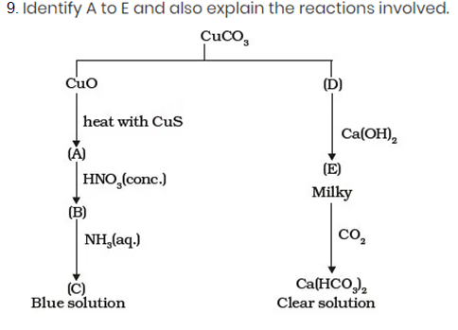
10. When a chromite ore (A) is fused with sodium carbonate in free excess of air and the product is dissolved in water, a yellow solution of compound (B) is obtained. After treatment of this yellow solution with sulphuric acid, compound (C) can be crystallised from the solution. When compound (C) is treated with KCl, orange crystals of compound (D) crystallise out. Identify A to D and also explain the reactions.
11. When an oxide of manganese (A) is fused with KOH in the presence of an oxidising agent and dissolved in water, it gives a dark green solution of
compound (B). Compound (B) disproportionates in neutral or acidic solution to give purple compound (C). An alkaline solution of compound (C) oxidises potassium iodide solution to a compound (D) and compound (A) is also formed. Identify compounds A to D and also explain the reactions involved.
12. On the basis of Lanthanoid contraction, explain the following :
(i) Nature of bonding in La₂O₃ and Lu₂O₃.
(ii) Trends in the stability of oxo salts of lanthanides from La to Lu.
(iii) Stability of the complexes of lanthanides.
(iv) Radii of 4d and 5d block elements.
(v) Trends in acidic character of lanthanide oxides.
13. A violet compound of manganese (A) decomposes on heating to liberate oxygen and compounds (B) and (C) of manganese are formed. Compound (C) reacts with KOH in the presence of potassium nitrate to give compound (B). On heating compound (C) with conc. H₂SO₄ and NaCl, chlorine gas is liberated and a compound (D) of manganese along with other products is formed. Identify compounds A to D and also explain the reactions involved.
14. a. Explain why the colour of KMnO₄ disappear when oxalic acid is added to its solution in acidic medium.
b. Reactivity of transition elements decreases almost regularly from Sc to Cu. Explain.
15. When orange solution containing Cr₂O₇^{2–} ion is treated with an alkali, a yellow solution is formed and when H⁺ ions are added to yellow solution, an orange solution is obtained. Explain why does this happen?
16. Though both Cr²⁺ and Mn³⁺ have d⁴ configuration, yet Cr²⁺ is reducing while Mn³⁺ is oxidizing. Explain.

